U18CO018

Shubham Shekhaliya

OS - Assignment-2

1-> Shell script Program to accept a character and check whether it is an Lower case alphabet, Upper case alphabet, A digit, Special symbol, Vowel Using case control structure

Code:-

echo "Please enter a charcter"

read c

case $c in

    [0-9])

        echo "Digit"

        ;;

    [a-z])

        echo "Small letter"

        ;;

    [A-Z])

        echo "Capital letter"

        ;;

    \*)

        echo "Special Charcter"

        ;;

esac

case $c in

    [aeiouAEIOU]) echo "A vowel";;

esac

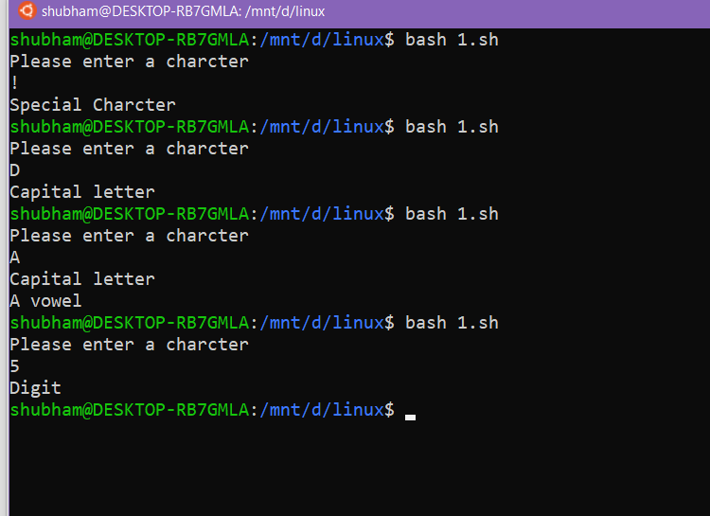

2-> Using case .. esac structure

Find the number of users logged into the system, Print the calendar for current year, Print the date

Code:-

ch=1

while [ $ch -gt 0 ]

do

    echo "Select Any one option"

    echo "1-> Number of Users Logged Into System"

    echo "2-> Print Calendar for current year"

    echo "3->print thr date"

    read d

    case $d in

        1) who | wc -l

        ;;

        2) cal 2021

        ;;

        3) date

        ;;

        \*)break

    esac

    echo "Do u wish to Continue(1/0)"

    read ch

done

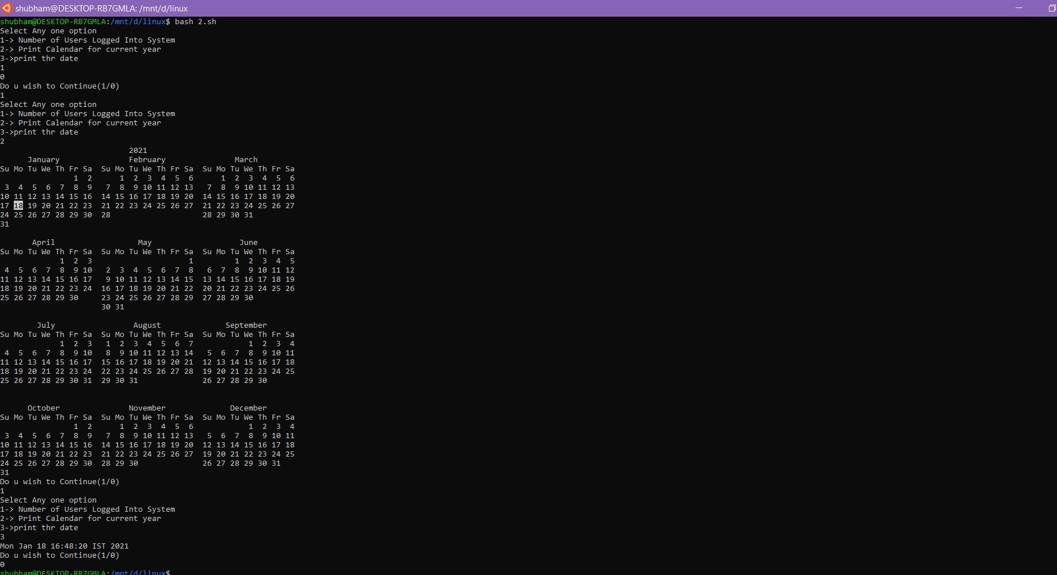

3-> Shell Script Program to check whether given file is a directory or not.

Code:-

echo "Enter the filename"

read fn

if [ -f $fn ]

then

    echo "It is a file"

else

    echo "It is a directory"

fi

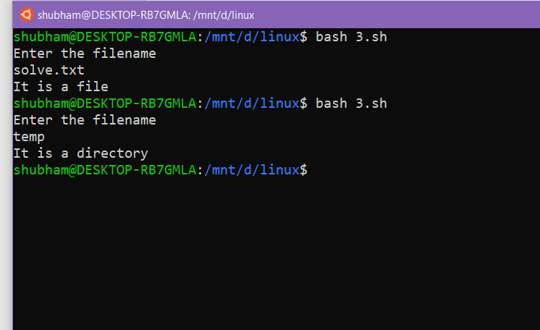

4-> Shell Script Program to Count number of files in a Directory.

Code:-

echo "Number of Files: "

k=0

for fi in \*

do

if [ -f $fi ]

then

    k=`expr $k + 1`

fi

done

echo $k

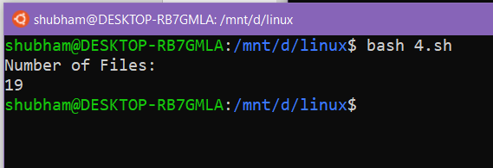

5-> Shell Script Program to copy contents of one file to another.

Code:-

echo "Enter the source file"

read a

echo "Enter the destination file"

read b

cp $a $b

After Code Execution Both Files

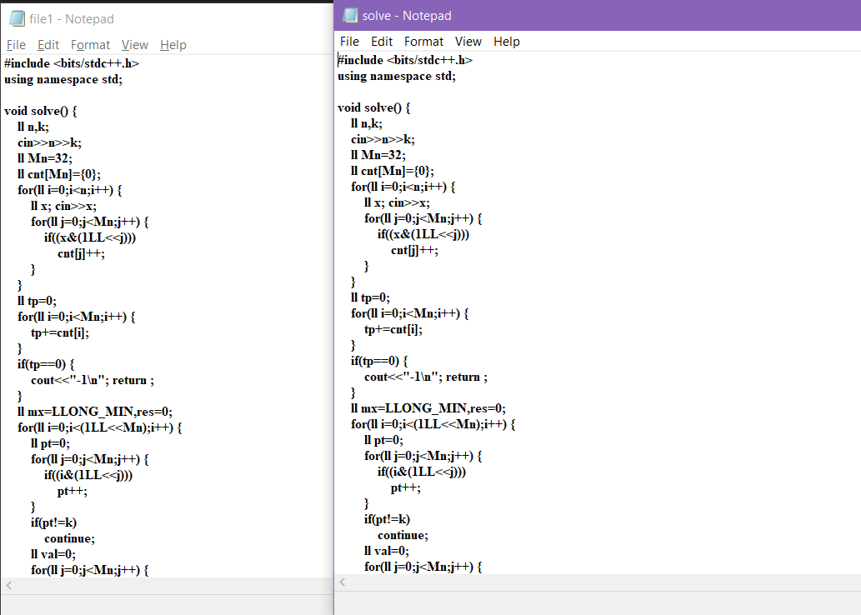

6-> Write a shell script to add two numbers supplied by user and supplied as command line argument.

Code:-

sum=$(($1+$2))

echo "Sum = $sum"

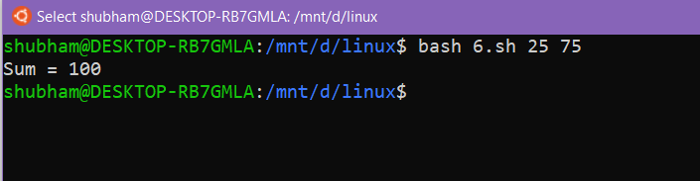

7-> Write a shell script to find out biggest number form given three numbers. Numbers are supplied by command line argument.

Code:-

if [ $1 -gt $2 ] && [ $1 -gt $3 ]

then

    echo "Greatest Number is -> $1"

elif [ $2 -gt $1 ] && [ $2 -gt $3 ]

then

    echo "Greatest Number is -> $2"

else

    echo "Greatest Number is -> $3"

fi

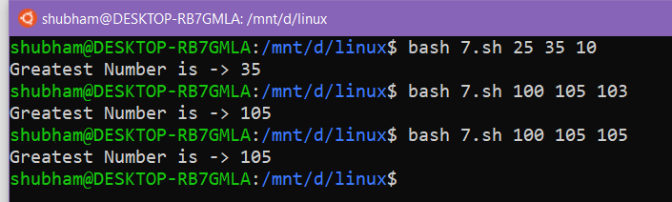

8-> Implement simple calculator. Numbers are supplied by command line

argument.

Code:-

echo "Enter Choice :"

echo "1. Addition"

echo "2. Subtraction"

echo "3. Multiplication"

echo "4. Division"

read ch

res=""

case $ch in

    1) echo "$1 + $2 = $(($1+$2))"

    ;;

    2) echo "$1 - $2 = $(($1-$2))"

    ;;

    3) echo "$1 \* $2 = $(($1\*$2))";

    ;;

    4) echo "$1 / $2 = $(($1/$2))"

    ;;

esac

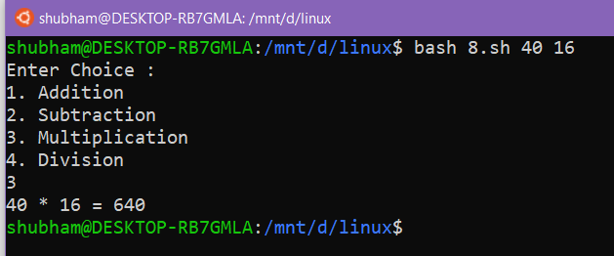

9-> Write a shell script to print numbers in descending order using while loop.

Code:-

numbers=(10 -29 33 67 -6 7 -10)

for (( i=0 ; i < ${#numbers[@]}; i++ ))

do

    for (( j=0 ; j < ${#numbers[@]}; j++ ))

    do

      if [[ ${numbers[$j]} -gt  ${numbers[$i]} ]]

      then

        tmp=${numbers[$i]}

        numbers[$i]=${numbers[$j]}

        numbers[$j]=${tmp}

      fi

    done

done

n=${#numbers[@]}

n=$(($n-1))

while [ $n -gt -1 ]

do

    echo ${numbers[$n]}

    n=$(($n-1))

done

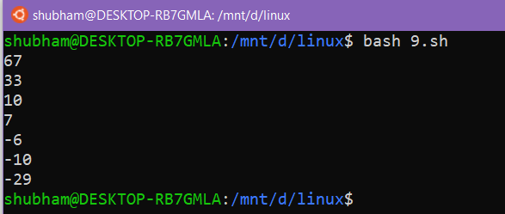

10-> Write a shell script to create a simple calculator using switch-case

statement.

Code:-

echo "Enter First Number"

read a;

echo "Enter Second Number"

read b;

echo "Enter Choice :"

echo "1. Addition"

echo "2. Subtraction"

echo "3. Multiplication"

echo "4. Division"

read ch

res=""

case $ch in

    1) echo "$a + $b = $(($a+$b))"

    ;;

    2) echo "$a - $b = $(($a-$b))"

    ;;

    3) echo "$a \* $b = $(($a\*$b))";

    ;;

    4) echo "$a / $b = $(($a/$b))"

    ;;

esac

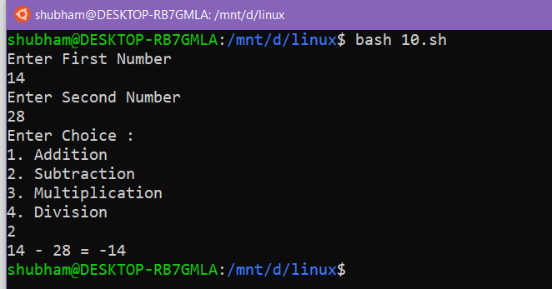

11-> Write a shell script to print given number in reverse order.

Code:-

echo "Enter a Number"

read n

s=0

while [ $n -gt 0 ]

do

r=$(($n%10))

s=$(($s\*10 + $r))

n=$(($n/10))

done

echo "Reverse of it is" $s

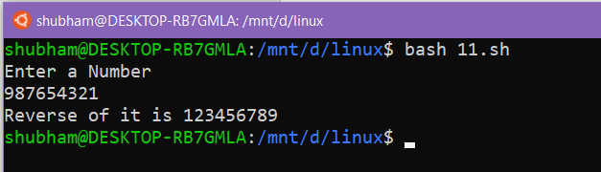

12-> Write a shell script to print sum of all digits of a given number.

Code:-

echo "Enter a Number"

read n

s=0

while [ $n -gt 0 ]

do

s=$(($s + $n%10))

n=$(($n/10))

done

echo "Sum of digits " $s

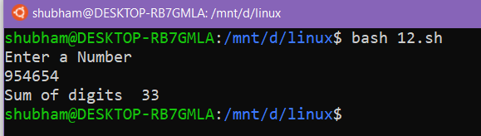

13-> Find the factorial value of given input number.

Code:-

echo "Enter a Number"

read n

p=n

s=1

while [ $n -gt 0 ]

do

s=$(($s\*$n))

n=$(($n-1))

done

echo "Factorial of $p is " $s

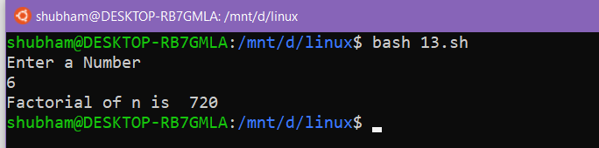

14-> Generate and display Fibonacci series.

Code:-

echo "Enter Maximum limit : "

read n

f1=0

f2=1

echo "Fibonacci sequence : "

for((i=0;i<n;i++))

do

    echo $f1

    temp=$f2

    f2=$(($f1+$f2))

    f1=$temp

done

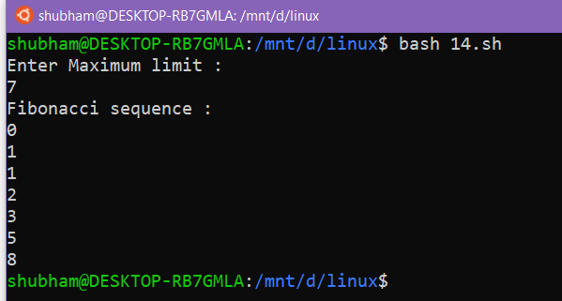

15-> Display all even numbers within given range.

Code:-

echo "Enter Starting Number: "

read l

echo "Enter Ending Number: "

read r

for((i=l;i<=r;i++))

do

    tp=$(($i%2))

    if [ $tp -ne 1 ]

    then

        echo $i

    fi

done

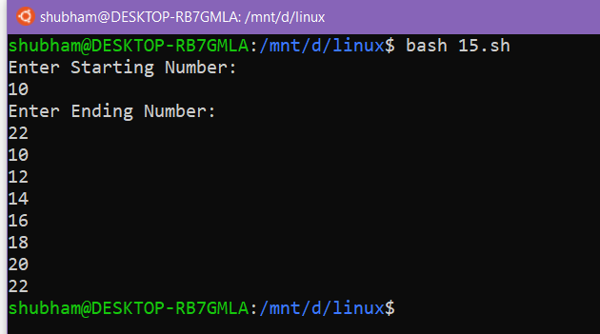

16-> Find out number of characters, words and lines from a given file.

Code:-

echo "Enter the filename"

read file

w=`cat $file | wc -w`

c=`cat $file | wc -c`

l=`grep -c "." $file`

echo "Number of characters in $file is $c"

echo "Number of words in $file is $w"

echo "Number of lines in $file is $l"

